- Detect whether the given input string is keyword or not:
//program 1: detect keyword or not keyword
#include <stdio.h>
#include <string.h>
#define MAX 5
#define max() {}
int main() {
char keyword[32][10]={
"auto","double","int","struct","break","else","long",
"switch","case","enum","register","typedef","char",
"extern","return","union","const","float","short",
"unsigned","continue","for","signed","void","default",
"goto","sizeof","voltile","do","if","static","while"
} ;
char str[20];
puts("Enter a string");
gets(str);
int flag=0,i;
for(i = 0; i < 32; i++) {
if(strcmp(str,keyword[i])==0) {
flag=1;
}
}
if(flag==1)
printf("%s is a keyword",str);
else
printf("%s is not a keyword",str);
}

- A sample program is given below that splits the contents of a .text file using space(‘ ‘):
#include <iostream>  #include <fstream>  #include <string>  #include <sstream>  using namespace std;  int main() {  ifstream input("split_text.txt"); string line;  while (getline(input, line, ' ')) {  cout << line << '\n';  }  return 0;  } | split_text.txt  Hello World! I am CPP.  position = initial + rate * 60

Sample output:
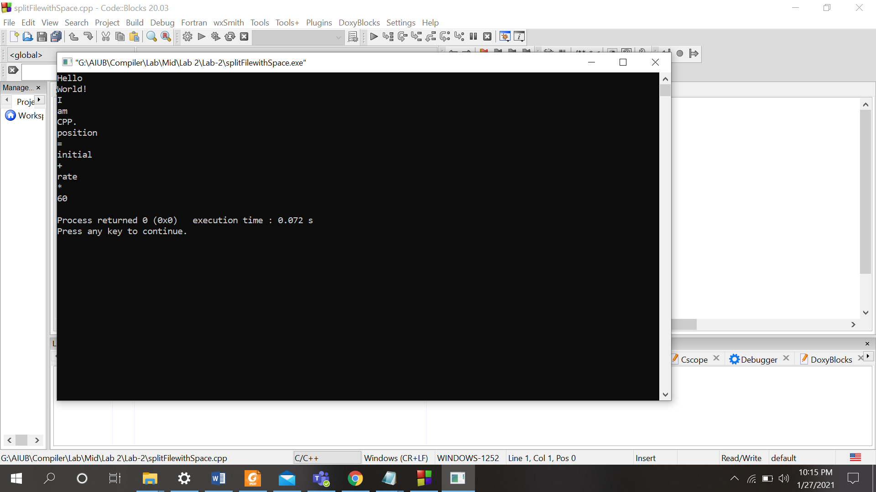

- Here are some practice problem of fseek()

#include <stdio.h>  int main () {  FILE *fp;  fp = fopen("file.txt","w");  fputs("This is tutorialspoint.com", fp);  fseek( fp, 0, SEEK_SET );  fputs("C Programming", fp);  fclose(fp);  return(0);  } | Output:  file.txt  C Programmingialspoint.com

A simple change of the above program:
#include <stdio.h>  int main () {  FILE *fp;  fp = fopen("file.txt","w");  fputs("This is tutorialspoint.com", fp);  fseek( fp, 14, SEEK_SET );  fputs("C Programming", fp);  fclose(fp);  return(0);  } | Output:  file.txt  This is tutoriC Programming

- A program that reads a text file and identify the vowels and consonants:

Input.txt

Hello, World!
This is your first program in this lab.

programFile.cpp
#include <fstream>

int main()
{
FILE *fp;
int vowel=0,consonant=0;
char ch;
char message[200];

fp=fopen("input.txt","r");

if(fp==NULL)
{
printf("Source can't be opened");
exit(-1);
}
while(!feof(fp))
{
fgets(message, 200, fp);
printf("%s", message);
}
printf("\n\n");

fseek(fp, 0, SEEK_SET);

while(ch!=EOF)
{
ch=fgetc(fp);
if((ch=='a')||(ch=='A')||(ch=='e')||(ch=='E')||(ch=='i')||(ch=='I')||(ch=='o') ||(ch=='O')||(ch=='u')||(ch=='U'))
{
vowel++;
printf("(%c) ", ch);
}
else if((ch>=65&&ch<=90)||(ch>=97&&ch<=122))
{
consonant++;
printf("%c ", ch);
}
}
fclose(fp);
printf("\n\nNumber of vowels are = %d\nNumber of consonants are = %d",vowel,consonant);
return 0;
}

Output
